BSNL CORPORATE OFFICE  Broadband-operation Cell,  Sixth Floor, Statesman House,  Barakhamba Road  New Delhi 110001  Ph: 23766994 Fax: 23766995 | 

No. 12-4/2008-BBO 9th March, 2009

Most Urgent

To

All Chief General Managers
Territorial/Metro Telecom Circles

Sub: Outsourcing of the Maintenance of Broadband Services.

Ref: Letter No. 64-31/04-BB dated 31.5.07

In a reference made by Shri R.L. Dube, Ex-Director(Plg.&NS), BSNL addressed to CMD on the subject cited above, it is mentioned that though the instructions have been issued for outsourcing of maintenance of broadband services, vide above noted referred letter(copy enclosed), but most of the circles have not yet implemented the same, causing poor maintenance of broadband services.

It is therefore requested to kindly send us the status of outsourcing of broadband maintenance services in your circle for information of CMD within 3 days on email gautamkumar40@gmail.com or FAX on 011-23766995.

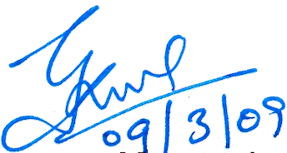

(Gautam Kumar)
Dy General Manager(BBO-I)

